Supplement and Fitness Shop

Software Development Plan

Version <1.0>

Revision History

|  |  |  |  |
| --- | --- | --- | --- |
| **Date** | **Version** | **Description** | **Author** |
| <15/10/2024> | <1.0> | Write part 2, 4 | Võ Hoàng Anh Khoa |
| <15/10/2024> | <1.1> | Write part 3 | Nguyễn Trần Đức Thiện |
| <21/10/2024> | <1.2> | Change part 3 | Nguyễn Trần Đức Thiện |
| <22/10/2024> | <1.3> | Change part 4 | Nguyễn Đình Kiên |
| <6/11/2024> | <1.4> | Add section 2.3, 3.1 | Võ Hoàng Anh Khoa |
| <6/11/2024> | <1.5> | Add and change part 4 | Nguyễn Trần Đức Thiện |

Table of Contents

**1.** **Introduction 4**

**2.** **Project Overview 4**

*2.1* *Project Purpose, Scope, and Objectives 4*

*2.2* *Assumptions and Constraints 4*

*2.3* *Project Deliverables 4*

**3.** **Project Organization 4**

*3.1* *Organizational Structure 4*

*3.2* *Roles and Responsibilities 4*

**4.** **Management Process 4**

*4.1* *Project Estimates 4*

*4.2* *Project Plan 4*

4.2.1 Phase and Iteration Plan 5

4.2.2 Releases 5

4.2.3 Project Schedule 5

4.2.4 Project Resourcing 5

*4.3* *Project Monitoring and Control 5*

4.3.1 Reporting 5

4.3.2 Risk Management 5

4.3.3 Configuration Management 6

Software Development Plan

# Introduction

Supplement and Fitness Shop is your one-stop destination for high-quality supplements and fitness products, designed to help you achieve your health and wellness goals. Our product line is carefully curated to provide a range of supplements that enhance energy, support recovery, and promote overall fitness. Whether you're a professional athlete or just beginning your fitness journey, Supplement and Fitness Shop offers trusted products made with premium ingredients to fuel your progress. We are committed to delivering excellence and transparency, ensuring that every product meets the highest standards of quality and safety.

# Project Overview

## Project Purpose, Scope, and Objectives

Purpose :

* To create an online platform that allows customers to browse and purchase a variety of high-quality fitness supplements.
* To offer personalized fitness coaching through a dedicated personal trainer service that helps users achieve their fitness goals.
* To provide a community-driven space where users can engage in fitness-related discussions, share advice, and support one another in their health journeys.

Scope:

- The scope of the project encompasses the development of a fully functional online store that includes typical e-commerce features such as user registration, login, logout, product ratings, and order management. In addition to the shopping features, the platform will deliver value-added services such as a forum for fitness discussions, a personal trainer service, and tools for tracking nutrition and calories. The website will cater to both general users and administrators, ensuring distinct access and permissions based on user roles.

Objectives:

* Develop a user-friendly online store for fitness supplements and products.
* Implement features such as login, logout, product ratings, and user/admin permissions.
* Provide a forum for users to discuss fitness topics, share experiences, and seek advice.
* Offer a personal trainer service to guide users in their fitness journeys.
* Integrate a calorie-counting tool to help users track their nutrition and fitness goals.
* Ensure a secure, scalable, and responsive website that works across all devices.

## Assumptions and Constraints

* Group : 5 members, no more changes
* Time requirement : 6 months deadline
* Task achievement : The website needed to be developed with 3 roles demonstrated and at last 10 functions.
* Budget : No budget constraints.

## Project Deliverables

Document :

* A detailed document describing the project’s goals scope, assumptions, and key deliverables.
* Deadline: Each 2 weeks

Test plan and test cases :

* A detailed test plan and a set of test cases to check the web’s functionality.
* Deadline: Draft by November 10, 2024, with iterative updates after each phase.

Final product :

* The web application ís fully functional, tested, and deployed.
* Deadline: Targeted completion by December 22, 2024.

User manual :

* A detailed guild explaining how to use the application
* Deadline: Completed alongside final product delivery on December 22, 2024.

# Project Organization

## Organizational Structure

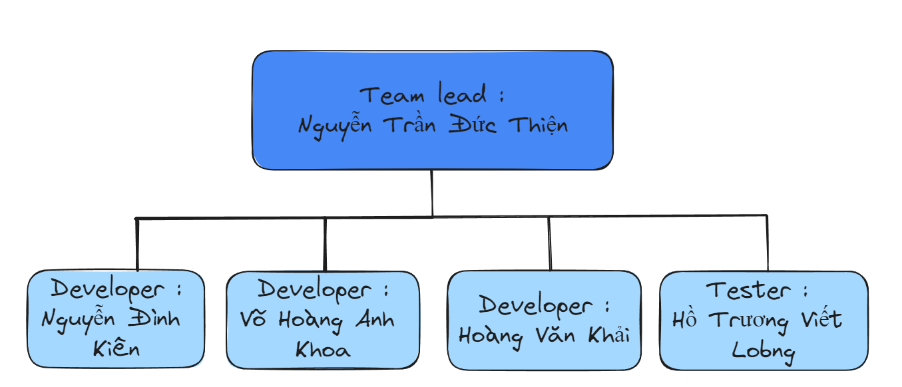

|  |  |  |
| --- | --- | --- |
| **Member** | **Role** | **Responsibilities** |
| Nguyễn Trần Đức Thiện | Team Leader, Frontend Developer, Test Designer | Project management, ensuring progress and quality of work, designing and developing the frontend for the website, preparing test strategies and test cases. |
| Nguyễn Đình Kiên | Backend Developer, Database Administrator, System Analyst | Managing the database, system analysis, and handling other supporting tasks within the project. |
| Võ Hoàng Anh Khoa | Fullstack Developer, API Specialist, Optimization Analyst | Focusing on backend and frontend development with a priority on API integration and optimization, improving system performance for smooth and efficient operation. |
| Hoàng Văn Khải | Frontend Developer, Test Designer, Business Analyst | Designing the web interface, optimizing user experience, preparing test strategies and test cases, supporting business requirements analysis for the project. |
| Hồ Trương Viết Long | Test Designer, Tester/QA Engineer, System Analyst, Backend Developer | Designing and executing test cases, ensuring overall system quality and testing, analyzing the system, and addressing any arising technical issues. Support other backend developers with their issues |

## Roles and Responsibilities

|  |  |
| --- | --- |
| **Roles** | **Responsibilities** |
| Project Manager | * Responsible for managing the overall Project Management * Establishing a set of practices that ensure the integrity and quality of project artifacts * Ensuring stakeholder satisfaction which means minimizing uncertainty, avoiding any unwanted surprises, and involving their clients in the project. * Organizing and motivating a project team. * Ensuring all members submit their work on time. |
| System Analyst | * Maintaining and upgrading existing systems as required * Designing new computer systems and frameworks * Troubleshooting technical issues * Creating system guidelines and manuals for the organization. * Structuring and prioritizing business requirements and communicating plans with stakeholders for review and approval |
| Business Analyst | * Identifying and prioritizing the organization's functional and technical needs and requirements * Understanding business strategies, goals, and requirements * Planning enterprise architecture (the structure of a business) * Forecasting, budgeting, and performing both variance analysis and financial analysis |
| Database Administrator | * Working with database software to find ways to store, organize, and manage data * Keeping databases up to date and managing database access * Helping with database design and development * Ensuring that databases meet user requirements * Testing and modifying databases to ensure that they operate reliably |
| Frontend Developer | * Determining the structure and design of web pages. * Developing features to enhance the user experience. * Optimizing web pages for maximum speed and scalability. * Striking a balance between functional and aesthetic design. * Building reusable code for future use. |
| Backend Developer | * Compile and analyze data, processes, and codes to troubleshoot problems and identify areas for improvement. * Developing ideas for new programs, products, or features by monitoring industry developments and trends. * Participating in continuing education and training to remain current on best practices, learn new programming languages, and better assist other team members. |
| Test Designer | * Preparing test strategies, and test cases for each part of the requirement and also doing the testing. * Testing plan creation and execution of test scripts. * Working with software developers and project support teams and identifying business requirements and mapping to test cases. |
| Tester/QA Engineer | Responsible for executing testing, including test set-up and execution, evaluation of test execution and recovery from errors, and assessing the results of test and logging identified defects. |

# Management Process

## Project Estimates

None

## Project Plan

Our project is divided into 3 **Phases** (Inception, Elaboration, Construction) and 5 **Sprints** (~5 PAs).

### PA0 & PA1 (**INCEPTION PHASE**)

Start: 10/14/2024

Due: 10/27/2024

Output: Vision document, project plan, initial requirements

Tasks:

1. Draft Plan: Đức Thiện
2. Initial Requirements: Anh Khoa, Đình Kiên
3. Analysis Feasibility: Văn Khải
4. Vision Document: Viết Long

Jira:

### PA2 (**SPRINT 1 - ELABORATION PHASE**)

Start: 10/28/2024

Due: 11/10/2024

Output: Detail Requirements, Draft General Design

Tasks:

1. Detail Requirements: Đức Thiện, Đình Kiên, Viết Long
2. Initial Requirements: Anh Khoa, Văn Khải

Jira:

Achievements: PA1 submission, General Design Of The Product

### PA3 (**SPRINT 2 - ELABORATION PHASE**)

Start: 11/11/2024

Due: 11/24/2024

Output: Detail Design Web Pages, Detail Design Back-end, Test Planning

Tasks:

* + - 1. Detail Design Web Pages : Đức Thiện, Văn Khải
      2. Detail Design Back-end : Đình Kiên, Anh Khoa
      3. Test planning : Viết Long

Jira:

### PA4 (**SPRINT 1 - CONSTRUCTION PHASE)**

Start: 11/25/2024

Due: 12/8/2024

Output: Build the first working product

Tasks:

Key Product Functionality : Anh Khoa

UI/UX Implementation : Đức Thiện

Back-end Development : Đình Kiên

Good Quality Interactions : Văn Khải

Testing and Debugging : Viết Long

Jira:

### PA5 (**SPRINT 2 - CONSTRUCTION PHASE)**

Start: 12/9/2024

Due: 12/22/2024

Output: Optimization, release 1.0 version product.

Tasks:

* + - 1. Optimization and Performance Improvement : Đức Thiện, Đình Kiên
      2. User Interface Enhancement : Văn Khải
      3. Testing : Viết Long
      4. Deployment : Anh Khoa

Jira:

## Project Monitoring and Control

### Reporting

* Weekly report
* Weekly meeting
* Progress Dashboards (Jira)

### Risk Management

*[Identify risks in your project. The risks should be prioritized, and shorted according to their priority.]*

|  |  |  |  |  |  |  |
| --- | --- | --- | --- | --- | --- | --- |
| *Risk ID* | *Risk Description* | *Probability* | *Impact* | *Risk Exposure* | *Priority* | *Mitigation Strategy or Contingency Plan* |
|  |  |  |  | *=Probability * Impact* |  |  |
|  |  |  |  |  |  |  |
|  |  |  |  |  |  |  |

### Configuration Management

* Moodle for posting and submitting assignments
* Facebook Group for general notifications, class discussions, and questions/answers.
* GitHub for managing source code and related files : <https://github.com/thienbanho/SE-Project>
* Discord and Slack for discussions and interactions among group members : <https://discord.gg/mRGTZ7WJ>
* Jira for organizing into sprints.
* Google Doc: Writing formal reports and documents.